Landing, Login, and Enrollment Pages Development

Braden Abbey

CST 499: Capstone for Computer Software Technology

Amr Elchouemi

10-17-2022

Before we can begin to go off and start coding we need to first make sure we establish a local connection. We can do this by using something like XAMPP for PHP, MariaDB and perl. Xamp gives us local sql database access and local file access for using .php files. So below we will take a look into how to install XAMPP and get our website started. We will be looking at making various pages as well as our SQL database.

In order to install XAMPP we will want to go out to a web browser and go to <https://blog.udemy.com/xampp-tutorial/> to get a step by step guide on how to install XAMPP on your machine. Once XAMPP is installed you will launch the XAMPP control panel and then from here we will click the start button next to APACHE which is used for processing the HTTP request and is the default web server application (*How to install xampp on windows ?* GeeksforGeeks, 2022, January 28). We will then want to wait for PID and Ports to populate, when this happens we know we are on the right track. Once the ports and PID are up we can then open a web browser of our choice such as Edge or Chrome. For this I used chrome and typed in localhost/ in the address bar in order to access the main localhost/ page for XAMPP like in the image below.

After we have XAMPP open and we typed in localhost/ and see the above image we know that so far we are on the right track. The next step is to start writing out our code, this is done in notepad. So we will open a .txt document and rename it to .php and give it a name of our choosing. Once this is done we will open the .PHP file and write our code and then once done we need to save it. We will save this .PHP file back to the default folder for XAMPP. For an example mine is c:\xampp\htdocs as its installed locally and the folder is htdocs. If you did not install XAMPP locally then you will need to locate which drive you saved to. In the HTdocs folder I made a folder called capstone which is where I will be saving all of my .PHP files to in order to complete the course enrollment system. So for my landing page I named it Landingpage.php and to access it I am going to type <http://localhost/capstone/landingpage.php>, once there we will see the below:

Now when we continue to build on this landingpage we will be saving all .PHP files into the capstone folder so we can access them in the same spot.

**Landing Page source code:**

**Login Page Screenshot & Source Code:**

**Registration Page Screenshot and Source Code:**

Once we fill out the registration form we then post the results and they get added to the SQL database by the sql data.php file which is below. The dqldata.php file makes a database connection by using:

<?php

$servername = "localhost";

$username = "root";

$password = "";

$dbname = "student registration";

// Create connection

$conn = new mysqli($servername, $username, $password, $dbname);

// Check connection

if ($conn->connect_error) {

die("Connection failed: " . $conn->connect_error);

}

This makes the connection to the database and I then do an insert of:

$sql = "INSERT INTO registration_table

VALUES ('$Email', '$Password', '$First', '$Last','$Address1','$Address2', '$City', '$State', '$ZIP', '$Phone', '$Degree')";

Once this is done we close the connection to the sql database by using:

if ($conn->query($sql) === TRUE) {

echo "New record created successfully";

} else {

echo "Error: " . $sql . "<br>" . $conn->error;

}

$conn->close();

?>

Next we have the SQL database that I set up. I typed in localhost/phpMyAdmin and got to PHPmyadmin and from here I created a new database, and then created a new table called registration information. With this I realized nothing was going over to my table when the registration page was filled out then realized the word “information” is a word you cannot use so I made registration_table and my data posted successfully. I manually made my tables but you could use code on the sql tab to make your table by using

CREATE TABLE registartion (  
    email varchar,  
    password varchar(255),  
    FirstName varchar(255),  
   lastname varchar(255),  
    City varchar(255)  
);

*(MySQL CREATE TABLE Statement*. MySQL create table statement, n.d.).

This is just a brief example and to pull data you can use the following in the screenshot:

**SQL Database Screenshot:**

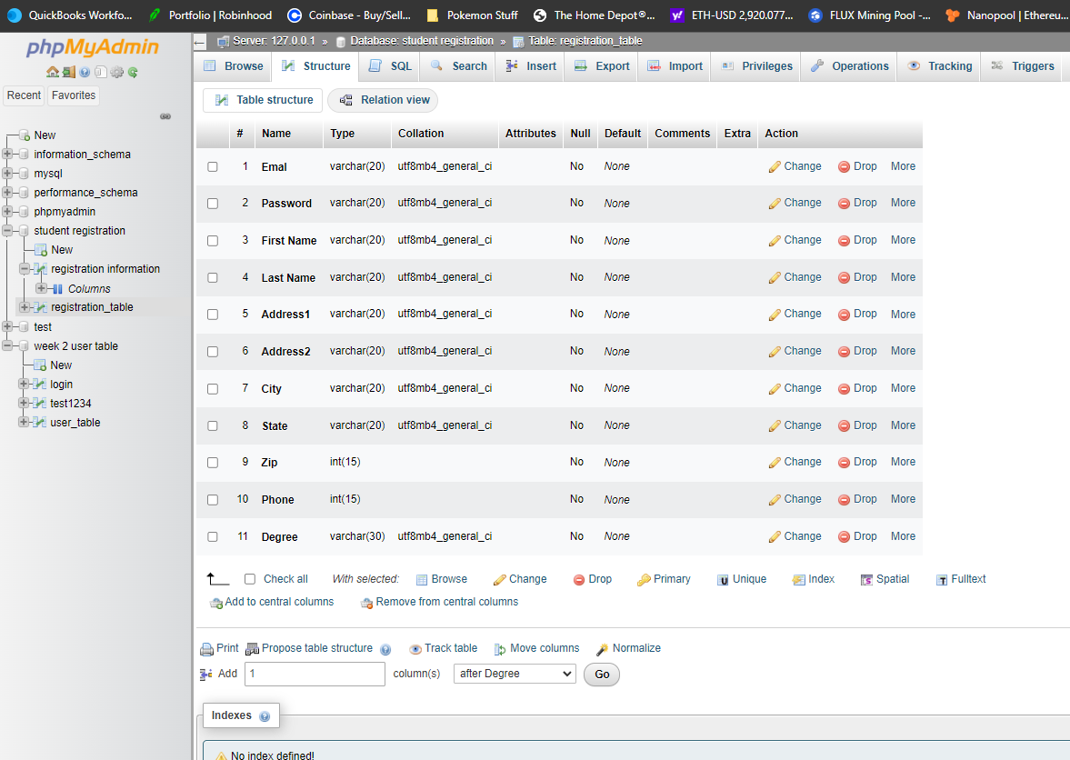

So as we can see there are some steps that we need to do before we can begin coding. We first need to set up XAMPP and then make our SQL database. Once this happens we can begin making our .PHP files and then writing out our code for our system. A long the way we need to make sure we are paying attention to where we are saving our files as we need to be I the local XAMPP folder in order to access them. From my screenshots and code screenshots above you can see the database I have set up as well as my code for the start of my course enrollment system.

**References**

*How to install xampp on windows ?* GeeksforGeeks. (2022, January 28). Retrieved October 17, 2022, from <https://www.geeksforgeeks.org/how-to-install-xampp-on-windows/#:~:text=Choose%20the%20root%20directory%20path,of%20the%20XAMPP%20Setup%20wizard>.

Mikoluk, K. (2013, September 18). *Xampp tutorial: How to use XAMPP to run your own web server*. Udemy Blog. Retrieved October 17, 2022, from https://blog.udemy.com/xampp-tutorial/

*MySQL CREATE TABLE Statement*. MySQL create table statement. (n.d.). Retrieved October 17, 2022, from https://www.w3schools.com/mysql/mysql_create_table.asp